Bioconductor Adoption
Use Case & Test Data Document
V1.2

Executive Summary

The caBIG Bioconductor project exposes Bioconductor/R functionalities as web services available through caGRID. It enables easy access to R/Bioconductor package from other programming languages such as Java. It also enables individuals who have developed cutting-edge statistical analysis packages to provide their services within the caGrid environment.

The use cases can be categorized into two groups: web service consumer and web service producer. As a web service consumer, we would like to be able to access three packages as web service from other languages such as Java. As a web service producer, we would like to be able to add a Bioconductor package developed by Northwestern University as a web service and be able to consume it in a different language such as Java.

Testing and use cases from the adopter will be more data-driven, since these use cases will be used for the following purposes:
1) to validate the requirement specification from the developer
2) to develop test procedures
3) to provide examples in the user manual

Thus, we will describe more specific information about the data along the use cases in details, including
1) biological motivations, especially cancer-related applications
2) expected results, if known

Four use cases and associated dataset are described in this document to provide tests for functionalities in the following Bioconductor packages:
1) affy: analyzing Affymetrix microarray data
2) PROcess: analyzing SELDI-TOF proteomics data
3) DNAcopy: analyzing array CGH data for genomic DNA aberrations
4) A self-developed Bioconductor package (to be determined): testing the procedures of adding user-developed packages to caGRID web service.

Northwestern University
Deliverable 2, Task 2.1.1 in the SOW
May 1, 2006

Document change history

Version | Date | Description
Draft-1 | 05/01/06 | John Osborne started draft
Draft-2 | 05/04/06 | Simon Lin added test data.
Draft-3 | 05/05/06 | John Osborne, minor corrections
Draft-4 | 05/05/06 | Pan Du, add a new use case
Draft-4 | 05/05/06 | Warren Kibbe, reviewed
Draft-5 | 05/09/06 | Julie Zhu, grouped use cases into consumer and producer category
V1.0 | 05/05/06 | Simon Lin, added figures
V1.1 | 05/12/06 | Sent out to developers
V1.2 | 05/12/06 | Discussed with Denise; references added.

Table of Contents

1 Introduction and history of this document 1
1.1 Organization of the document 2
1.2 Scope 2
1.3 Personnel 2
2 Test Data 2
2.1 Affymetrix Data Set 2
2.2 SELDI-TOF Data Set 3
2.3 Array CGH Data Set 3
3 Abbreviations 4

Introduction and history of this document
This document will describe the data sets being used to test the application and explain the rationale why they are selected.

Use cases from the adopter will be more data-focused, since these use cases will be used for the following purposes:
1) to validate the requirement specification from the developer
2) to develop test procedures
3) to provide examples in the user manual

The use cases can be categorized into two groups. The first we call web service consumer and the second we call web service producer. As a web service consumer, we would like to be able to access three packages as web service from other languages such as Java. As a web service producer, we would like to be able to add a Bioconductor package developed by Northwestern University as a web service and be able to consume it in a different language such as Java.

This document will also provide basis for the forthcoming Testing Procedures Document (Deliverable 7, Task 2.4.1). We will compare the results between the traditional local invocation and web service invocation of the R/Bioconductor functions for the following four packages to test whether the web service provides the R/Bioconductor functionalities as intended.

Organization of the document
The first section of this document will provide a general overview of the test data, including its scope and personnel who will perform the testing activities. The next section will discuss the choice of test data. Abbreviations and references will be provided at the end of the document.

Scope

Selected functionalities from the following Bioconductor packages will be exposed to the caGrid environment. It covers three major cancer biology research areas: transcriptomics, proteomics, and genomics. The affy package is one the most frequently cited analysis methodology for microarray data analysis.

Bioconductor Package | Cancer biology applications
affy | Processing Affymetrix microarray data to profile mRNA expression levels
PROcess | Find protein biomarkers from SELDI-TOF proteomics data
DNAcopy | Identifying genomic DNA aberrations from array CGH data

Personnel
Simon Lin and Julie Zhu selected all data sets. Simon Lin will oversee the project and the primary Bioconductor software tester will be Pan Du, with help from Dong Fu to address administration, network and caGRID network issues with the running of Bioconductor. All deliverable documentation will be generated by Pan Du with help from John Osborne and be reviewed by the rest of the team.

Test Data

Affymetrix Data Set

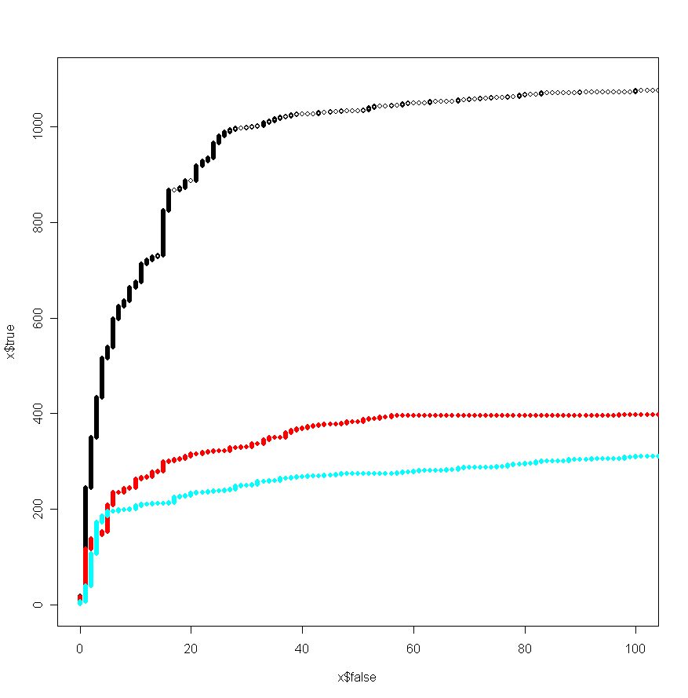
The primary data set used will be the “golden spike” experiment(Choe, et al., 2005), a cRNA spike in dataset useful for evaluating the effectiveness of analysis methods for Affymetrix arrays. This experiment consists of two samples, that were hybridized in triplicate to Affymetrix GeneChips® for a total of 6 chips. The constant or control sets consists of 3860 cRNAs of known concentration. The experimental hybridization set is identical to the control, but with a slightly increased amount of cRNA for a known set of selected genes. Knowing the answer will allow us to better compare our results to other microarray analysis software.

Figure 1. Reciver Operating Curve (ROC) of different processing methodologies to detect differentially expressed genes. Black: proble-level limma, red: RMA-limma, cyan: MAS5- limma

SELDI-TOF Data Set

A benchmark data set with a known “spike-in” peptide at 0, 0.4, 1, 2, 4, 6, and 10 ul will be used to test the data preprocessing procedures in PROcess.

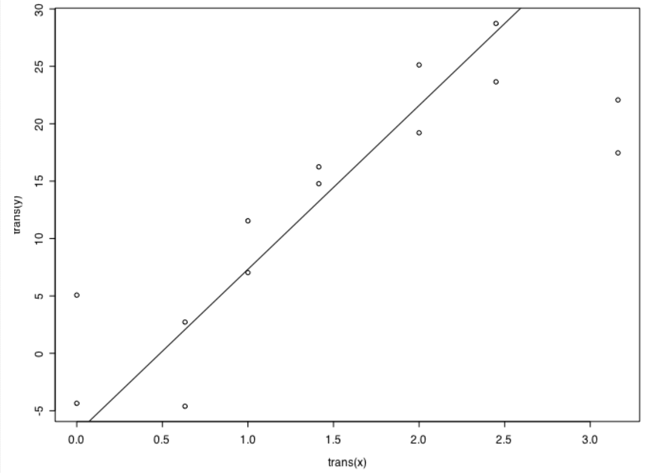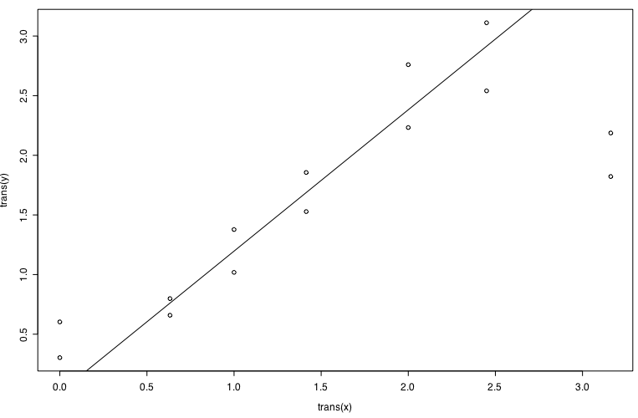
Figure 2. Linearity of measurement responses. Before (left) and after (right) preprocessing.

To further test the parallel processing capabilities, a data set of 7,148 SELDI-TOF spectra from six fractions of 34 patients will be tested.

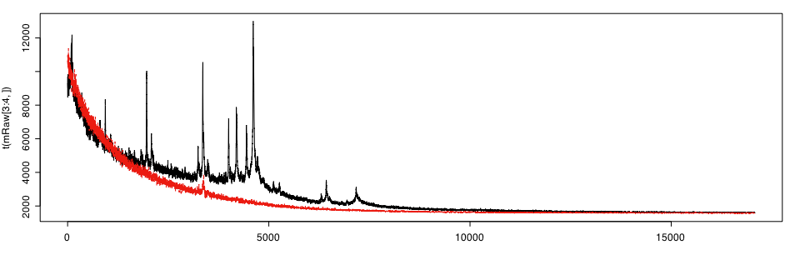
Figure 3. Two example SELDI-TOF spectra of patient serum.

Array CGH Data Set

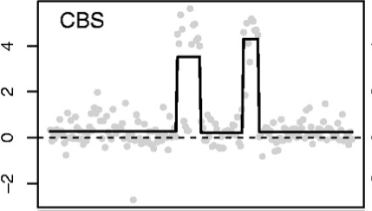
Simulated data with different level of difficulties (as measured by signal-to-noise ratio) will be provided to test the application’s capability to recover the true signal.

Real data from chromosome 13 in a Glioblastoma Multiforme sample (GBM31) will be tested to find the gain/lose regions.

These data will be reformatted for the consumption by the DNAcopy package(Lai, et al., 2005).

Figure 4. Example array CGH data. Raw measurements are plotted as grey points.

Abbreviations
API – Application Programming Interface
ca – Common prefix for cancer related activities and objects at NCI
caGRID – Grid infrastructure to support data and tool sharing across cancer centers
CPU – Central Processing Unit
Genepix – Microarray Analysis software and a file type from Axon Instruments for analyzing spotted microarray data
ISO – International Standards Organization
JVM – Java Virtual Machine
OSX – Operating System X (latest Macintosh Operating System)
NCI – National Cancer Institute
R – Open source implementation of the S programming language, used for statistical analysis
RAM – Random Access Memory
SVG – Support Vector Graphics
SELDI-TOF -- Surface-enhanced laser desorption ionization - time of flight
UML – Unified Modeling Language
XML – Extensible Markup Language

References

Choe, S.E., Boutros, M., Michelson, A.M., Church, G.M. and Halfon, M.S. (2005) Preferred analysis methods for Affymetrix GeneChips revealed by a wholly defined control dataset, Genome Biol, 6, R16.
Lai, W.R., Johnson, M.D., Kucherlapati, R. and Park, P.J. (2005) Comparative analysis of algorithms for identifying amplifications and deletions in array CGH data, Bioinformatics, 21, 3763-3770.

